SIMULATION OF SHUNT ACTIVE FILTER FOR AIRCRAFT ELECTRICAL SYSTEM

João Paulo de Souza Oliveira, joao.souza@embraer.com.br¹
Roberto d’Amore, damore@ita.br²

¹ Embraer, Gavião Peixoto, Brasil
² Instituto Tecnológico de Aeronáutica, São José dos Campos, Brasil

Abstract. The power quality in aircraft electrical systems became an important issue due to the continuous expansion of electrical loads connected to the distribution system. This study focuses on the power quality improvement and power factor correction by the utilization of active filtering connected in the terminals of non-linear loads. A simulation is proposed with a shunt active filter connected at the power input of an electrohydraulic actuator operating in an electrical grid. The results obtained comprise the system voltages waveforms within the aeronautical standard MIL-STD 704F constraints for distortion factor and distortion spectrum

Keywords: Power Quality, Total Harmonic Distortion, Active Filter

- INTRODUCTION

The increase of the aircraft operational costs associated with the fuel consumption drives the development of new aircraft technologies (Babikian et al., 2002). In this scenario, the aviation market has changed the design perception regarding the electrical system, replacing hydraulic and pneumatic’s power source to equivalent electrical ones, creating the concept of the More Electrical Aircraft (MEA) (Moir, 1999).
This context raised the relevance of the EPGDS (Electrical Power Generation and Distribution System) in the role of aircraft operational safety. Thus, the electrical system needs to have a greater reliability and operates in such a way to avoid failures of the equipment connected to the grid. However, the increase of the amount of non-linear loads has raised the harmonic distortion content introduced in the EPGDS (Singer et al., 2012), diminishing the power quality and becoming a subject of study in aircraft operational safety.
To improve the power quality with the reduction of the total harmonic distortion (THD), some conditioners must be connected in the equipment power input and/or in the distribution grid. The implementation of these conditioners must consider the reliability, weight and cost to be feasible in aircraft design.
In this context, some topologies to increase the power quality are already used in the aircraft electrical system, such as the multi-pulse rectifiers (Zhu and Ma, 2014; Gong et al., 2003; 2005). However, its weight and volume make this topology applicable only to specific equipment.
With the increase of the non-linear loads applied to the electrical grid, along with the requirements to ensure power quality, some alternatives of power factor correction have been proposed. In this scenario, the use of a shunt active filter applied in an aircraft is an item of recent study, considering different active filters topologies (Chen et al., 2012a; Chen and Chen, 2012; Chen et al., 2012b).
This article analyses the use of a shunt active filter to improve the power quality in the aircraft EPGDS. It starts by reviewing the active filter operation, the instantaneous power theory, and continues discussing control techniques. A simulation is presented to analyze the shunt active filter operation with three electrohydraulic actuators (EHA), which are non-linear loads used to control the aircraft latero-directional and longitudinal aerodynamics surfaces. The simulation model is compounded by the electrical generation and distribution system connected to EHAs with their respective shunt active filters.

- POWER QUALITY IN AIRCRAFT

The power quality in aircraft EPGDS is a concern which regards the airworthiness. The electrical equipment embedded in aircraft must be qualified to ensure the proper operation and integration. Thereby, the power quality is one of the subjects considered in the qualification tests, which are specified by standard test procedures issued by aeronautical authorities. The most used qualifications standards for electrical systems are the MIL-STD 704, which qualifies the EPGDS, and the DO-160 - Section 16, which qualifies the embedded electrical equipment. To ensure the proper equipment integration, the EPGDS and equipment must comply with these standards.
The non-linear loads inject harmonic distortion content in the system, inducing degradation in the power quality and decreasing the power factor. Furthermore, the increase in the number of electrical equipment connected in the grid enhances the degradation of the power quality. Thus, techniques for power factor correction must be applied in the EPGDS to limit the system parameters within the constraints of aeronautical standards.
Some techniques are already used in aircraft electrical system to increase the power factor and power quality. One of these techniques is the use of multi-pulse converters, which is most employed in high current rectifiers to improve the power quality. However, despite of the good reliability, they are bulky and heavy. There are some other topologies that are useful for harmonic content reduction, but their characteristics do not make them feasible to operate in the aircraft systems. Some of these topologies are the passive filters and power factor correction (PFC) converters. For the passive filters, despite of good reliability and low cost, the high weight is the main problem to its implementation in aircraft (Barruel et al., 2004). For the PFC converters, the downside lies in the low reliability and low density of energy conditioned (Zhu and Ma, 2014; Gong et al., 2003; 2005).
In this scenario, the active filter, due to its features as lightweight and fast response to load variation, appears to be a feasible topology to reduce the harmonic content and increase the power factor (Zhu and Ma, 2014; Chen et al., 2012a; Karatzaferis et al., 2013). There are some drawbacks in its use, as the high complexity and low reliability. However, the advances in power electronics are making them practical to be implemented in aircraft electrical system (Abdel-Hafez and Forsyth, 2009).

- ACTIVE FILTERS

The operation of active filters is based on the generation of voltages/currents to interact with the electrical grid waveforms to achieve a power factor equal to one. This is accomplished by measuring the voltage waveforms from the source and the current waveforms from the load to determine the reference currents to be set in a compensator, see Fig. (1) (Akagi, 2006). The compensator is given by a voltage source converter (VSC), which injects current waveforms with symmetrical values of harmonic components to compensate the harmonic content responsible for the power factor degradation.

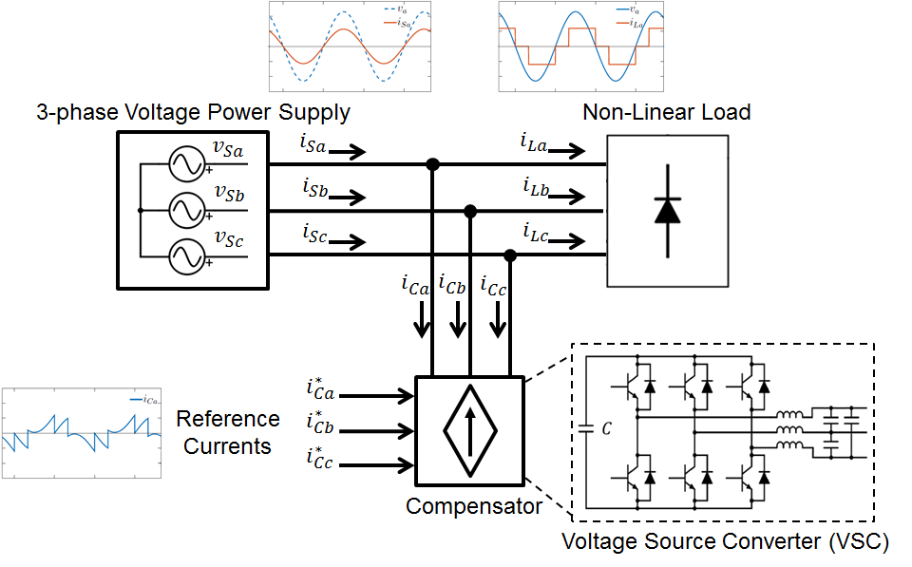

Figure 1. Shunt active filter

3.1. Instantaneous Power Theory

The instantaneous power theory was presented by Akagi (Akagi et al., 1984), which proposed new concepts for the instantaneous active and reactive electrical power. It can be used in three phase, three or four wire system and in steady or transient state (Akagi et al., 2007). In this theory, the manipulation of the active and reactive power calculations furnishes a tool to determine the currents that degrade the power factor, such as harmonic distortion and phase shift.
Considering a three-phase system, composed of the phases a, b and c, the instantaneous power theory is based in the coordinates transformation from the abc to αβ0. This is known as the Clarke Transformation and is shown in Eq. (1).

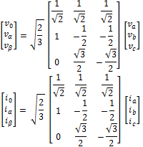 (1)

According to (Akagi et al., 2007), the instantaneous power is defined in Eq. (2), where the p₀, p and q are the instantaneous zero-sequence power, the active instantaneous power and the reactive instantaneous power, respectively (Akagi, 2006; Peng and Lai, 1996).

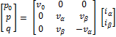 (2)

In the aircraft EPGDS, the three-phase voltages encountered in the electrical buses are balanced and the distribution of single-phase loads are defined so that the zero voltage sequence v₀ can be disregarded. With this consideration, the Eq. (2) can be simplified as the Eq. (3), where the instantaneous zero-sequence power is absent.

(3)

The reverse calculation, i.e., the determination of the currents i_{α} and i_{β} when the voltages v_{α} and v_{β} and the instantaneous power p and q are known is presented in Eq. (4).

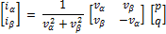 (4)

By definition, the active instantaneous power is composed of the energy that is swapped between two subsystems, whereas the reactive power is composed of the energy being swapped between the three phases of the system (Akagi et al., 1984; Peng and Lai, 1996) Furthermore, both p and q are defined as a composition of an average ( and ) and an oscillating ( and ) values, as defined in Eq. (5).

(5)

To create an active filter to achieve a power factor equal to 1, the only permitted power flowing in the transmission lines is the average value of the instantaneous active power (). To ensure this condition, the filter must inject in the lines currents with symmetrical values of the instantaneous reactive power (q) and the oscillating portion of the instantaneous active power (), these ones injected in the grid by the non-linear loads. By doing this, these powers are canceled in the same way as the current harmonic content. Thereby, the selection of power to be compensated and processed by the filter must contains the values of - and -q only.
The filter full operation is defined by the instantaneous power p and q calculation, followed by the selection of the power to be compensated, i.e., - and -q. Afterwards, the currents i_{α} and i_{β} are calculated using the Eq. (4) with the values - and -q, followed by the inverse Clarke transformation to acquire the current in abc coordinates to be applied as a reference in the compensator. The whole active filter reference calculator is shown in Fig. (2).

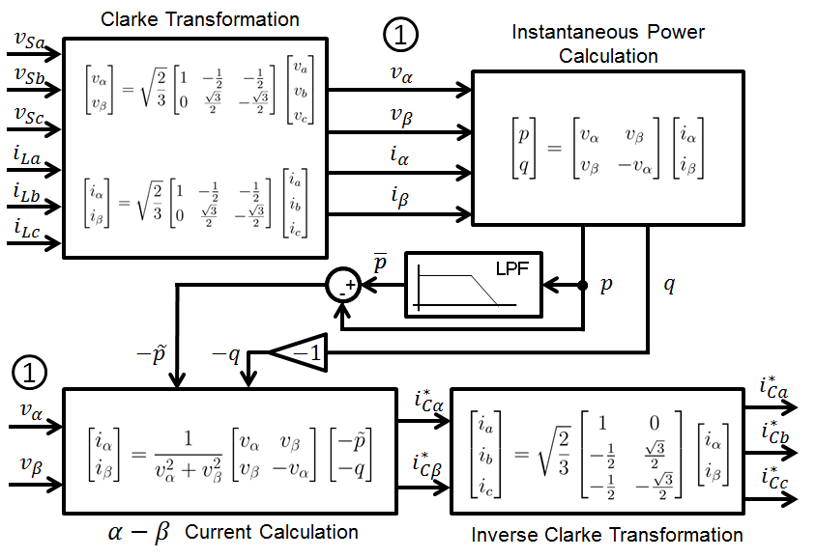

Figure 2. Active filter reference calculator

3.2. Control Strategy

The active filter specified in Fig. (2) presents very effective to set the current reference at the compensator input for mitigation of the electrical system harmonic content. However, this calculation procedure is valid to produce sinusoidal current waveforms only when the voltages measured and used in the filter input are pure sine waves (Akagi et al., 2007). This happens insofar as the filter operates allowing only the mean value of the active instantaneous power flowing in the circuit. Therefore, the use of a non-sinusoidal voltage waveform in the input of the filter requires a non-sinusoidal current waveform to establish the power flow consisted of .
In aircraft electrical system, the voltage waveforms in the load terminals are presented as non-sinusoidal, however, they are still limited by aeronautical standards. As the voltages used in the active filter are measured at this point, the filter defined as per Fig. (2) is not optimal for power quality purposes. In some cases, it may decrease the power quality and have an unstable operation depending the levels of harmonic distortion presented in the voltages waveforms (Akagi et al., 2007)
According to (Akagi et al., 2007) the p-q theory proves insufficient to create a current sine wave and a mean value of the active instantaneous power flow, simultaneously when distorted voltage waveforms are measured by the filter voltages probes. To overcome this problem, a control strategy based on the use of a positive-sequence voltage detector is employed to ensure a sinusoidal current control. This way, the power flow between the load and the source is not defined as the mean value of the active instantaneous power. In contrast, the control strategy relies on the appropriate sine wave current insertion to establish the proper power quality at the system.
The sinusoidal current control is designed using the positive-sequence voltage detector (PSVD), which operates to extract the fundamental positive-sequence component from the distorted voltages. The point of PSVD connection is between the loads terminals and active filter reference calculator (Fig. (2)). This component is required by the active filter to define the current shape to be applied in the electrical grid to create a sinusoidal waveform.
The positive-sequence voltage detector operates based on the p-q dual theory, where uses a phase locked loop (PLL) and the p-q theory to extract the fundamental frequency and amplitude of the distorted voltages (Akagi et al., 2007). The PLL is shown in Fig. (3) and operates acquiring the fundamental frequency and phase. The scheme shown in Fig. (4) uses the p-q theory and the information coming from the PLL to define the amplitude of the fundamental voltages component to be used in the active filter calculations.

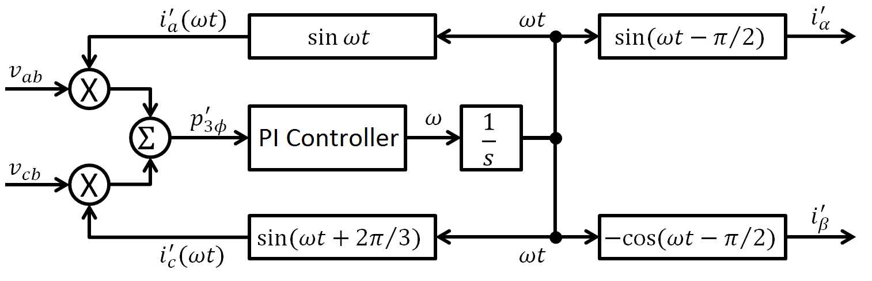

Figure 3. Phase locked loop

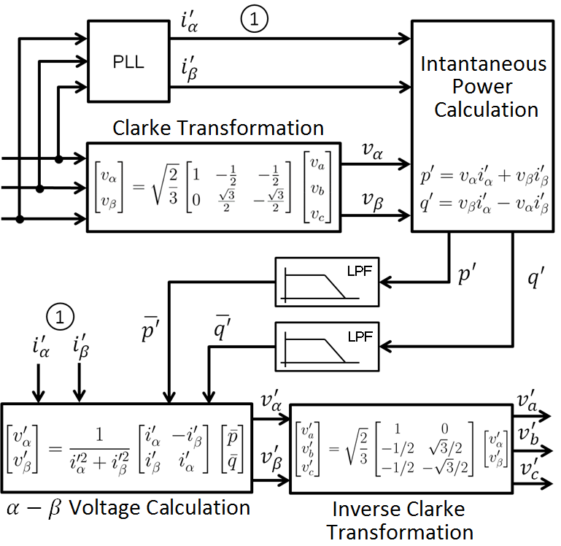

Figure 4. Positive-sequence detector

The operation of the active filter has some power loss mainly due to the VSC switching devices, which reduces the capacitor voltage, locate in the converter DC side. To avoid this voltage drop, a compensation strategy using a PI controller must be applied in the active filter. This closed-loop error signal is processed by the compensator, managing the power flow in the VSC to hold the capacitor voltage within a specifically reference.

- SIMULATION OF THE SHUNT ACTIVE FILTER OPERATING WITH AN ELECTROHYDRAULIC ACTUATOR

The operation of the shunt active filter in an aircraft electrical system was evaluated by simulation. The system is composed of the generation and distribution system and some loads constituted by electrohydraulic actuators with shunt active filters connected to its respective inputs.

4.1. Active Filter Model

The shunt active filter consists of a Current Reference Calculator and a Compensator, as shown in Fig. (5). This figure shows these parts with its respective internal sub-blocks. The Current Reference Calculator block is comprised by the Positive Sequence Detector (Fig. (4)) and the Active Filter Reference Calculator (Fig. (2)). These sub-blocks are responsible for the calculation algorithm (each sub-block presents its respective inputs and outputs signals) to determine the reference to be applied in the compensator. The Compensator is presented by the VSC with its respective hysteresis controller and capacitor voltage PI controller. This figure also shows the voltages and currents measurement probes connected in the electrical grid at the non-linear load terminals, where they acquire the signals for the active filter operation.
The reference calculator block defines the proper reference to be applied in the compensator. Its inputs are the load currents and the grid voltages measurements, while its output is the reference applied to the compensator. The compensator block consists of a VSC with its capacitor DC voltage regulated by a closed-loop controller. The compensator also has the hysteresis controller, which creates the commands applied to the VSC switching devices.
The shunt active filter operation requires a passive capacitor filter applied in the transmission lines to eliminate the high frequency content injected in the system by the switching commutation (Akagi et al., 2007). Due to high switching commutation frequency, the passive filter is lightweight and does not impact significantly in the aircraft system. However, the presence of capacitors in the transmission lines may decrease the power factor due to the voltage and current phase shift. To eliminate this, inductors may be applied in the lines to compensate the reactive power flow.

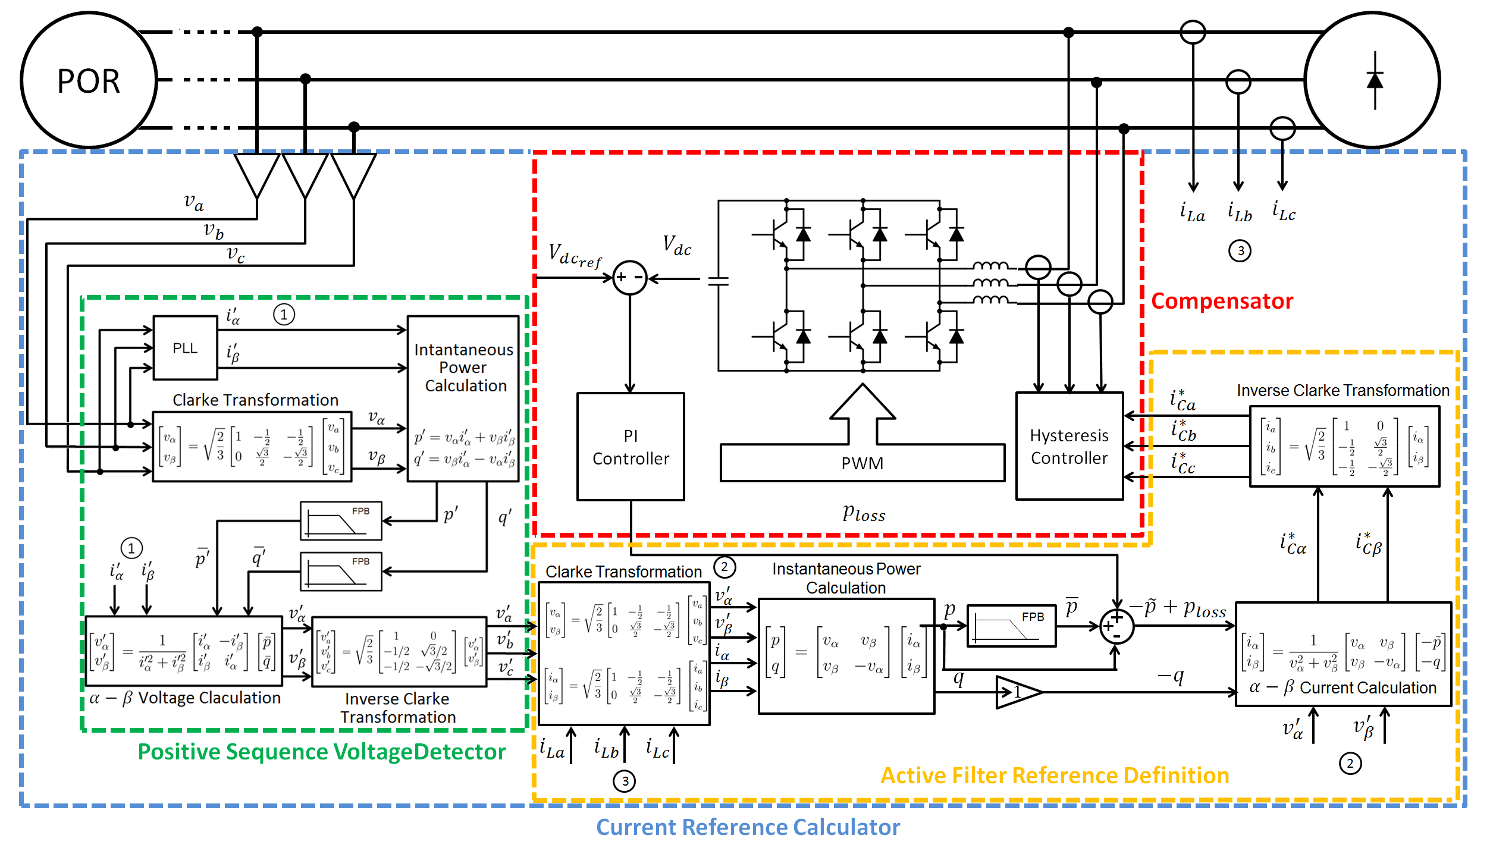

Figure 5. Shunt active filter scheme

4.2. Electrical System Model

The aircraft electrical system model considers the operation of the generation and distribution system with its respective non-idealities, which affect the power quality due to voltage drop. The simulation has a generator system, a power distribution system and three EHAs connected in parallel as the loads, see Fig. (6).
The generator system consists of a synchronous machine and a generator control unit (GCU). The GCU works as a field excitation controller to set the proper voltage in the POR. The synchronous machine also has resistance and inductive reactance connected in series with the voltage source to model the resistance and the inductance presented in the generator coils.
The power distribution system is composed of the transmission lines between the generator and the POR and between the POR and EHAs. Probes in the POR measure the system voltages levels to be sent as the reference input to the GCU. The power transmission lines are modeled as a resistance and a inductive reactance in series of each of the 3 phase lines.
The EHA is a non-linear load, since its input has a 3-phase diode bridge. The EHAs model has a 3 phase Graetz diode bridge with a controlled current source placed in its respective DC side. The controlled current source operation recreates the apparent power consumption of a real EHA. Thereby, this guarantees the simulation of the distorted current waveforms generated by the EHA in real operation.

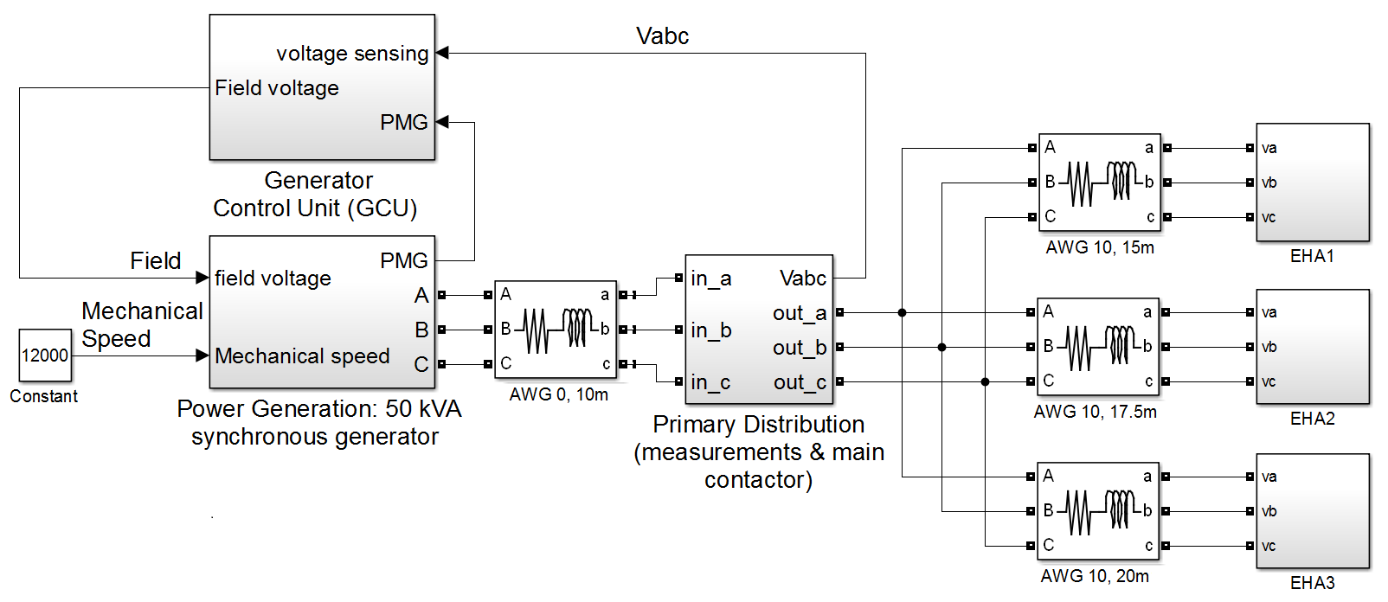

Figure 6. Electrical generation and distribution model

4.3. Results

The simulation results show the voltages and currents waveforms measured at the POR, the voltage frequency spectrum, the amplitude constraints defined by the MIL-STD 704F, and the calculated value of the voltage THD.
The test is divided in two conditions: the EHAs without operating and the EHAs starting their operation (maximum load). The results also show the cases where the active filters are connected and disconnected from the EHAs power input.
Fig. (7) shows the system waveforms without active filters in the EHAs power inputs, when the EHAs are not in operation. Fig (8) shows the waveforms with the active filters connected to the EHAs power input for the same period. In this case, the active filters degrade the power quality during this time interval, since the THD increases and the frequency spectrum presents more harmonic content. The noise is inserted in the system due to the commutation of the VSC switching devices. Thus, even with the presence of the capacitor filter in the lines, it was observed some high frequency content injected in the grid. However, the results are inside the limits defined by aeronautical standards.
Fig. (9) shows the system waveforms without active filters connected to the grid, when the EHAs are requiring maximum current. In the same time interval, Fig. (10) shows the waveforms with the active filters connected to the EHAs power input. During this interval, it is clear the active filter enhancement in the system power quality. Considering these results, the active filter mitigates the harmonic content and set it within the limits of the MIL-STD 704F.

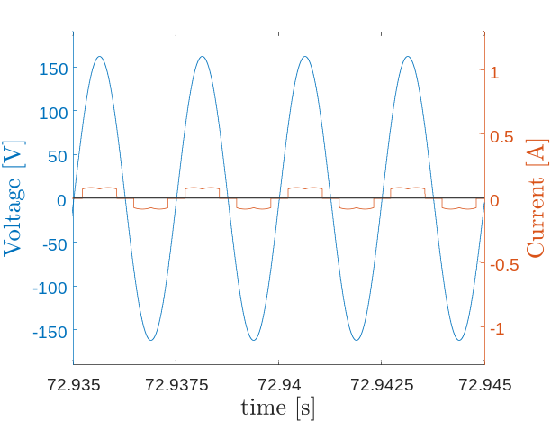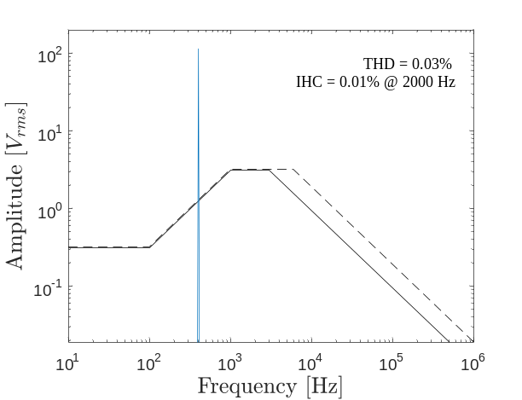

Figure 7. System without load and filter

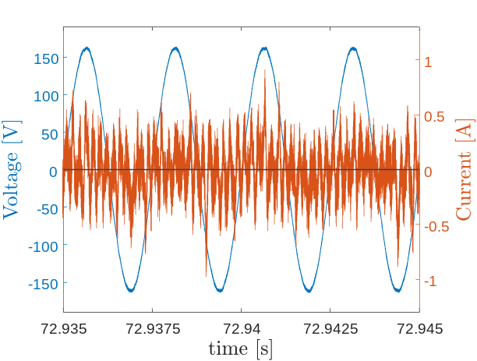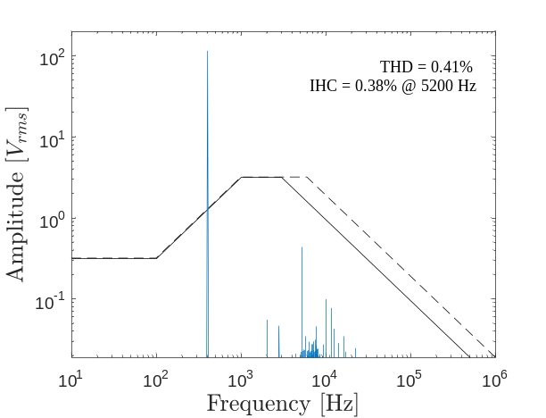

Figure 8. System without load and with filter

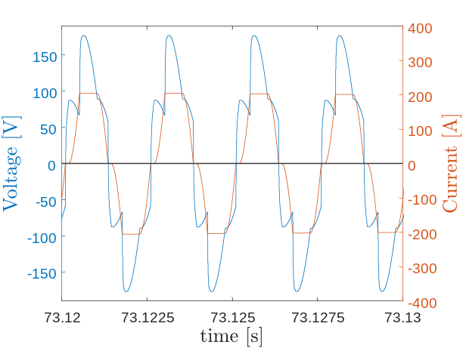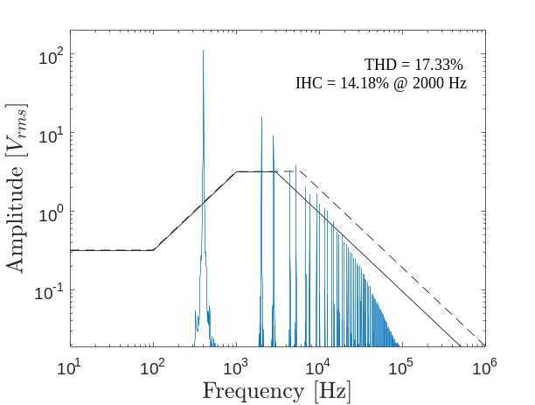

Figure 9. System with load and without filter

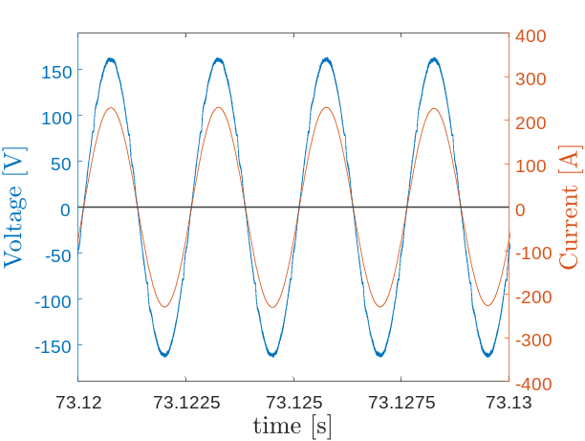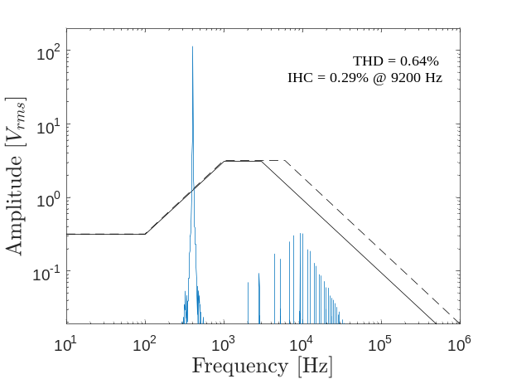

Figure 10. System with load and filter

- CONCLUSIONS

The simulation results showed a correct active filter operation under high load variation, keeping the voltage within the limits defined by the aeronautical standards in terms of harmonic content.
There are some drawbacks with non-linear loads connected with their respective active filters. In the case of low power consumption, the power quality is slightly degraded. However, the deterioration does not drive the system operation out of the aeronautical standards.
It should be noticed that even without load power consumption, the set composed of loads and filters draw current from the source. This is caused by the energy loss in the filter operation, mainly due to the non-idealities of the switching devices. This loss is not negligible in comparison with the energy drawn by the load operating in low consumption mode.

- REFERENCES

Abdel-Hafez, A. and Forsyth, A., 2009, “A review of more-electric aircraft”. Proceedings of the 13th International Conference on Aerospace Science & Aviation Technology, Cairo: Military Technical College.
Akagi, H., 2006, “Modern active filters and traditional passive filters”. Bulletin of the Polish Academy of Sciences, Vol. 54, n. 3,
Akagi, H., Kanazawa, Y. and Nabae, A., 1984, “Instantaneous reactive power compensators comprising switching devices without energy storage components”. IEEE Transactions on industry applications, n. 3, pp. 625-630.
Akagi, H., Watanabe, E. H. and Aredes, M., 2007, “Instantaneous Power Theory and Applications to Power Conditioning”, Chichester: John Wiley & Sons.
Babikian, R., Lukachko, S. P. and Waitz, I. A., 2002, “The historical fuel efficiency characteristics of regional aircraft from technological, operational, and cost perspectives”. Journal of Air Transport Management, Vol. 8. N. 6, pp 389-400.
Barruel, F., Schanen, J. and Retiere, N., 2004, “Volumetric optimization of passive filter for power electronics input stage in the more electrical aircraft”. Proceedings of the 35th Annual Power Electronics Specialists Conference, Vol. 1, pp 433-438.
Chen, Z. and Chen, M., 2012, “A novel 400 Hz shunt active power filter for aircraft electrical power system”. Proceedings of the 7th International Power Electronics and Motion Control Conference, Vol. 4, pp 2838-2843.
Chen, Z., Luo, Y. and Chen, M., 2012a, “Control and performance of a cascaded shunt active power filter for aircraft electric power system”. IEEE Transactions on Industrial electronics, Vol. 59, n. 9, pp. 3614-3623.
Chen, Z., Wang, C., Chen, M. and Li, J., 2012b, “A research on cascade five-level aeronautical active power filter”. Proceedings of the 7th International Power Electronics and Motion Control Conference, Vol. 4, pp. 2732-2737.
Gong, G., Drofenik, U. and Kolar, J., 2003, “12-pulse rectifier for more electric aircraft applications”. Proceedings of the IEEE International Conference on Industrial Technology, Maribor. Vol. 2, pp. 1096-1101.
Gong, G., Heldwein, M. L., Drofenik, U., Miniböck, J., Mino, K. and Kolar, J. W., 2005, “Comparative evaluation of three-phase high-power-factor ac-dc converter concepts for application in future more electric aircraft”. IEEE Transactions on Industrial Electronics, Vol. 52, pp 727-737.
Karatzaferis, J., Papanikolaou, N., Tatakis, E., Loupis, M. and Spanoudakis, J., 2013, “Comparison and evaluation of power factor correction topologies for industrial applications”. Energy and Power Engineering, Vol. 5, n. 6, pp 401-410.
Moir, I., 1999, “More-electric aircraft-system considerations”. Proceedings of the IEEE Colloquium on Electrical Machines and Systems for the More Electric Aircraft, London.
Peng, F. Z. and Lai, J.S., 1996, “Generalized instantaneous reactive power theory for three-phase power systems”. IEEE Transactions on Instrumentation and Measurement, Vol. 45, pp. 293-297.
Singer, C., Guernsey, C. M., Gousy, J., Cottingham, J. D. and Frerichs, J., 2012, “Aircraft electrical power systems and nonlinear dynamic loads”. SAE International Journal of Aerospace, Vol. 5, pp. 447-454.
Zhu, S. and Ma, W., 2014, “Methods of aircraft grid harmonic reduction: A review”. Scholars Journal of Engineering and Technology. Vol. 2, pp. 270-275.

- RESPONSIBILITY NOTICE

The author(s) is (are) the only responsible for the printed material included in this paper.

